A

Project Report on

“**People Tracking Application (E-Tracking Application)**”

Submitted in partial fulfillment of completion of the course

Advanced Diploma in IT, Networking and Cloud

Submitted by:

|  |
| --- |
| **G Sachin Singh** |
| **Doly Tiwari** |
| **Daivshila Waghmare** |
| **Bhaira Ram Prajapati** |
| **Amit Kumar** |

  

Year 2022

**Abstract**

The title of our project is People Tracking. We have attempted to make an application of People Tracking by creating a portal with web technology. The objective of this project is to create a portal which would allow to store information and to be updated securely using a proper authentication and authorization about the users to track them. so its use and extension can be done without much endeavor. Even though this project is not exhaustive, the principal purpose of this exercise is to emphasize to awareness of tracking the people by storing data and getting insights of data and to find out the missing information about the users. This application can be used in any emergency situation/as a log book application/as a govt /private organization digital record dictionary.

**Acknowledgement**

We would like to express our sincere gratitude to several individuals and organizations for supporting us throughout our diploma study. First, we wish to express our sincere gratitude to our EDUENT trainer Mr. Mohammad Sarwar Sir & IBM mentors Mr. Sukanta Sarkar, Rahul Banga for his enthusiasm, patience, insightful comments, helpful information, practical advice and unceasing ideas that have helped us tremendously at all times in our study and writing of this project report. His immense knowledge, profound experience and professional expertise in computer science has enabled us to complete this project successfully.

We also wish to express my sincere thanks to the National Skill Training Institute, for accepting me into the diploma program. In addition, we are deeply indebted to the Ministry of Skill Development & Entrepreneurship and IBM for granting us the diploma course. This technical and financial support has enabled us to complete our diploma course studies successfully. Also, we are grateful of the faculty of NSTI for supporting us for course completion in the specific subject.

**Team Composition and Workload Division**

It was a great experience for all of us to work collaboratively. We understood each other where we can do better and fast. As per our understanding among each other we divided our tasks to be executed. We were daily having catchup calls among us and we were discussing about the work and its progress. We were successfully able to make it happen because we understand our weakness and strength, we helped each other whenever we need.

We divided the project as a part for each of us like

* UI Designer
* Database Schema Design Developer
* Database Developer
* Coe Business Logic Developer

It was very good positive experience for all of us to do in a team for the project.

**Table of Contents**

|  |  |  |
| --- | --- | --- |
| **Chapter. No.** | **Chapters** | **Page No.** |
| 1 | Introduction | 1 |
|  | 1.1 Background of Concept | 1 |
|  | 1.2 Project Motivation | 1 |
|  | 1.3 Overview | 1 |
|  | 1.4 Objectives | 2 |
| 2 | Literature review | 3 |
| 3 | Proposed Solution | 4 |
| 4 | Requirements | 5 |
|  | 4.1 Technology Stack | 5 |
|  | 4.2 Hardware | 5 |
|  | 4.3 Software | 5 |
|  | 4.4 Deployment Environment | 5 |
| 5 | User Requirements | 6 |
| 6 | Design Documentation | 7 |
|  | 6.1 Pictorial Representation of Model | 7 |
|  | 6.2 Functional Flow | 7 |
| 7 | Implementation Details | 9 |
|  | 7.1 User Signup | 9 |
|  | 7.2 User Login | 10 |
|  | 7.3 Raise a Request | 10 |
|  | 7.4 Check the Status of request | 11 |
|  | 7.5 Admin Updates Request | 12 |
| 8 | Testing | 13 |
| 9 | Deployment | 14 |
| 10 | Future Scope | 15 |
| 11 | Chapter 11: Conclusions and Reference | 16 |

1. **Introduction to Problem**
   1. **Background of Concept**

Our mission behind this project is to provide an online platform to help users / organizations in giving details regarding identification information and to track them. This application admin, user panels to use and view the records.

* 1. **Project Motivation**

Our Tracking application was designed in the thought process of knowing about people who went where in any emergency it means using this in scenario of Covid-19 pandemic is one of the best examples we found. In the absence of data about the people in lockdown was the biggest challenge for govt to recognize who is infected and who is not int that area without testing them, tracking data about users helps us to recognize them where users went, did they exposed into area of danger zone or a major group of people are gathering outside without any permission from govt helps in tracking the rate of change in the disease severity, across organizational or individual boundaries. Here we focus on digitally enabled commercial logbook among organizations and individuals.

**1.2 Overview**

A tracking system exists. Some are 'lag time' indicators, that is, the data is collected after an item has passed a point for example a add your name and 'real-time' or 'near real-time' like [Global Positioning Systems](https://en.wikipedia.org/wiki/Global_Positioning_System) (GPS) and details about user in web application. There are your name systems which require items to be scanned and [automatic identification](https://en.wikipedia.org/wiki/Automatic_identification_and_data_capture) ([RFID](https://en.wikipedia.org/wiki/RFID) auto-id) will be created automatically by the programmed software. For the most part, the tracking worlds are composed of discrete hardware and software systems for different applications. That is, your name systems are separate from  GPS systems are separate from active real time locating systems or [RTLS](https://en.wikipedia.org/wiki/Real-time_locating) for example, but due to the limited resources and possibility we chosen human enabled manual data storing procedure:

**1.3 Objectives**

To make software fast in processing, with good user interface so that user can know about Tracking application work well. Also, we focus on;

* Reduction of Management Cost for hard copies.
* Developing Time Efficiency.
* Providing a Unique facility for software as per user needs.
* Boosting the efficiency of Services.

1. **Literature Review**

Our brief research about the already existed solutions for the challenges what we are trying to solve helped our team a lot. We went through the solutions each but considering the collective results in the way they implemented was not satisfactory. They are failing at a point when they compared with each other. So, we thought that we no need to reinvent the wheel which is already exist but instead of that we can give a better shape by covering all those missing aspects in different existed solutions.

As a part of that we thought if we can choose web technology as a core part of application to be built upon then it will be very helpful for us to make the progress faster than other methods to approach. We made a blue print of implementing the real-time database-oriented data generation ad storing it as a log record.

The analysis was simple that the application can be stored in a centralized environment so it can be available to the organization 24x7 except in the technical troubleshooting period. We had a great resource from mall over the world to get started and implement them. We referred many popular websites, blogs, articles, e-books for implementing the solution.

But eventually there is always a limit for scope of implementing our projects it is either technical or resources what we have in our scope. So there might be little more things to be added but we can make them available so that it can easily available in future.

**3.Proposed Solution**

The proposed solution is to implement a web technology-based application which is able to record the data of people. So, we can track them where they are going. The main motto is to be able to identify the people who needs to go out in the period of emergencies, curfew’s, lockdowns with proper approval from the authorized department.

We implemented the 2 panels in the solution which is user and admin panel. Through this panels user can be able to operate the application. User can able to sign up and login and can request the approval and he can wait for the approval.

1. **REQUIREMENTS**

**4.1 Technology Stack**

We used web technology as a platform for application. We developed a web application for developing the software algorithm. Application developed in the concept of full stack development

**FRONT END:**

* HTML5 (Hypertext Markup Language)
* CSS3 (Cascading Style Sheet 3)
* JS (JavaScript)

**FRAMEOWRKS:**

* BOOTSTRAP (Twitter Open-Source UI Framework)

**BACKEND:**

* PHP (Preprocessor Hypertext Programming)

**DATABASE:**

* MYSQL (Microsoft Structured Query language)

**SERVER:**

* Apache Server

**4.2 Hardware**

* A minimum 500 MB of free disk space
* A minimum 64 MB of memory allocated to PHP
* A minimum of 50 MB of database

**4.3 Software**

* PHP 5.6 – 7.2
* MySQL 5.5 or Higher with InnoDB configuration supported.

**4.4 Deployment Environment**

* Windows hosting web server which consists of all the features and requirements listed above

1. **User Requirements**

User no need to have any special device or software to be installed to use the application. The following specifications are enough for user to use the application.

* A mobile phone / Tablet / Pc with minimum specifications in browser.
* A proper internet facility.
* A govt approved Identity
* Valid Email id
* Valid mobile number
* Necessary documents attached for requesting permission.

**6. Design Documentation**

**6.1 Pictorial Representation of Model:**

Here this is a Picturized Model for this project:



USER

PHP SERVER

SQL SERVER

ADMIN

**Application Hosted Environment**

3

**6.2 Functional Flow**

admin

user

Role

Success

Failed

Success

Failed

Confirm Result

Approval Action

View a Request

Final Result

Approval Waiting

Request

Success

Failed

Registration

Registration

Authentication

Authentication

Raise a request

Success

Failed

Failed

Success

**7. Implementation Details**

**7.1 User Signup:**

As an initial step user need to be registered in website using user signup portal

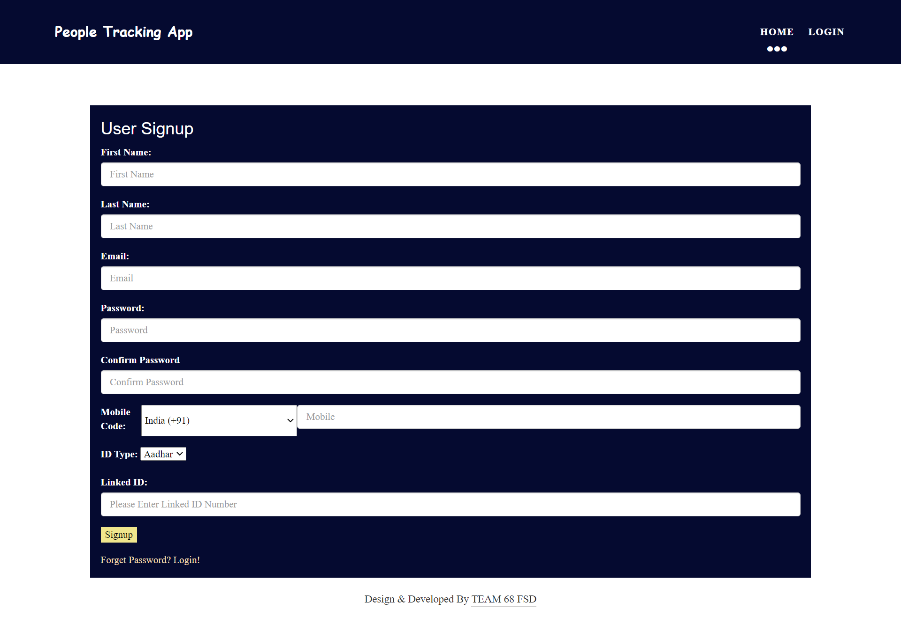

In this page user should give his email id, password, mobile number, his govt approved identity.

**7.2 User Login:**

In 2nd step user should login and should be authenticated by using the email and password

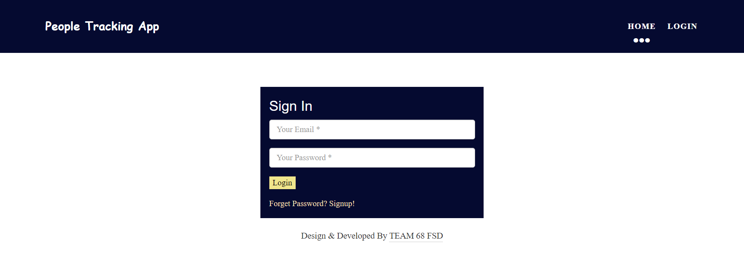

**7.3 Raise a Request:**

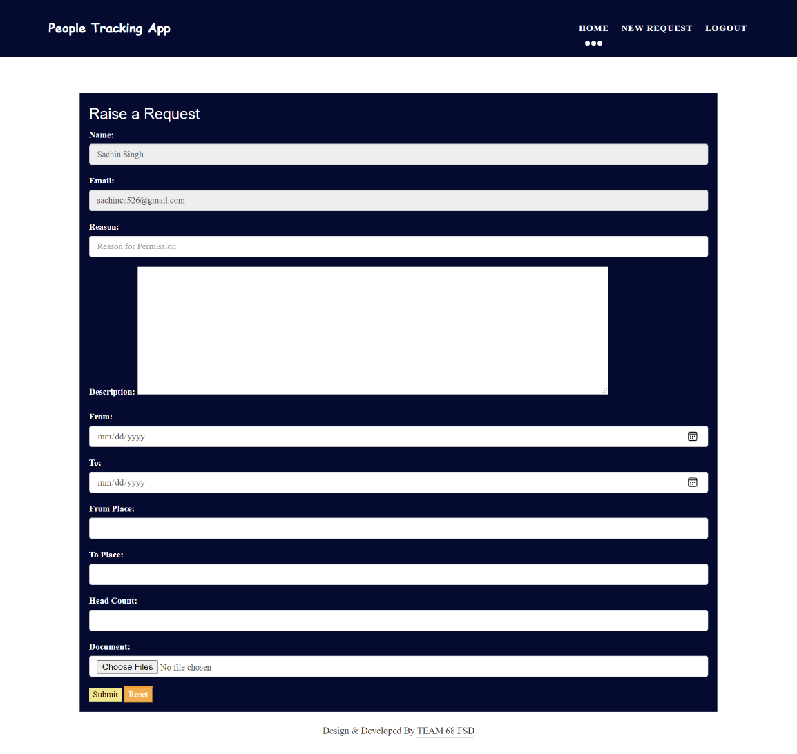 In third step user can request permission for approval he should give his details for getting approval

**7.4 Check the Status of Request:**

In this step user can check his request status by clicking on his unique generated RFID

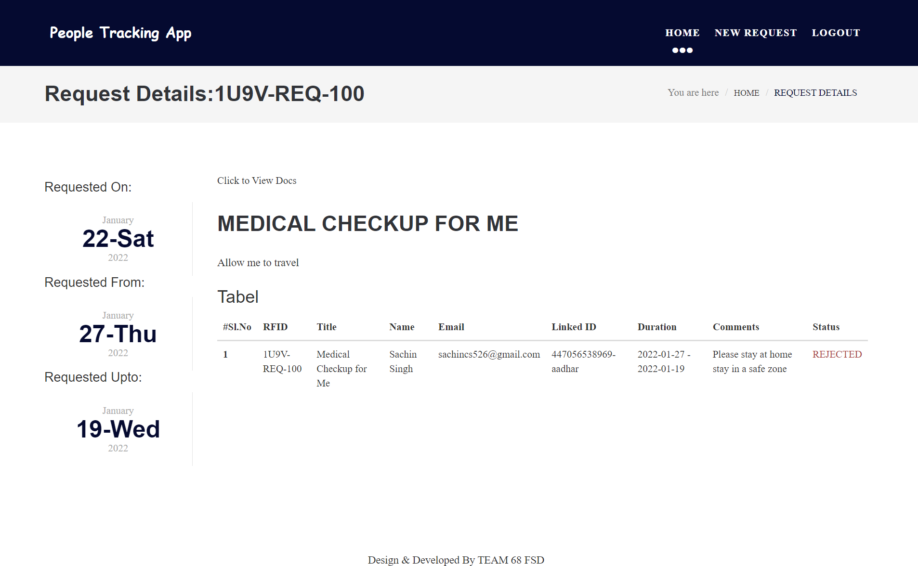

User can check his request status and he can get to know that either he can proceed or not with his request.

**7.5 Admin Updates Request:**

All the process of signup and login for admin is same as mentioned above for user. The thing where and admin and user differ is admin is able to provide permission and approval / reject / hold status for the request generated by user.

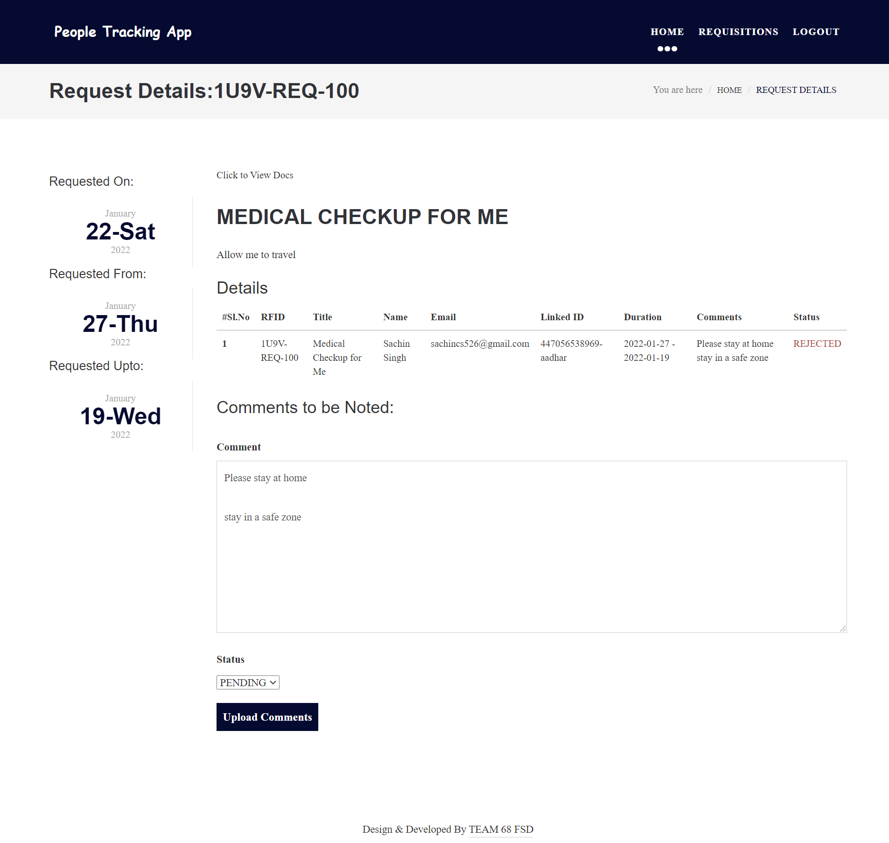

Admin can check the documents of proof uploaded by the user in the above request page by clicking on the link of “Click to view Docs”.

**8. Testing**

As a part of development, we did our testing too for the cases of failing the execution process by violating the rules of logic built and with the database configurations. We changed wherever the implementation needs to be changed. All the data type checking and proper validations have been taken care

The test cases like

* What if user fills non valid data?
* What if user give false data?
* How to handle the load of data: **but in this case we were completely dependent of the server configuration and there are some limitations based on the cost-effective solutions.**

All the unit test cases, Speed test cases also checked properly.

**9. Deployment**

For the deployment process we have taken the free resource of 000Webhost.com. The organization is providing the free hosting and database administration service with limited capacity of operating and we found it as good resource for students to develop and test projects.

We uploaded all the project files into the 000webhost file manager. Configured the database in phpMyAdmin and we were successfully hosted the application and after all validations and tests made successfully the live version of application is at:

<https://geriatric-receiver.000webhostapp.com/>

**10. Future Scope**

**Existed System Vs Proposed System Vs Future Scope**

|  |  |  |
| --- | --- | --- |
| Existed System | Proposed System | Future Development |
| Missing of Realtime Data | Realtime data can be generated | Timestamp based snapshot data storing |
| Physical records | Digital records | Digital record |
| Much time needed to process data | Time efficiency increased and data can be managed fast | Data processing speed can be increased |
| Security is less | More secured way t store but still vulnerable | Ai based encryption can be enabled |
| Cost of operation increases | Cost of operation is decreased | Cloud resources can be utilized so that cost get reduced |
| Manual Unique Identity | Proper validated Unique Identity for record | Cryptography Based Unique Identity |
| No GPS Positioning | No GPS Positioning but can be traced through the log entry | GPS can be enabled abled and user can be tracked time to time properly |

**11. Conclusion**

Hence all the details which we submitted for the project installation are can be seen in this documentation. We have given our best to work as a team and we succeeded for bringing the end solution of challenged facing by organization for tracking the people. Many more features can be implemented in future with hep of AI and wide variety of API services.

Project Code can be seen at:

[PeopleTrackingApplication/People Tracking App at main · sachin-developer/PeopleTrackingApplication (github.com)](https://github.com/sachin-developer/PeopleTrackingApplication/tree/main/People%20Tracking%20App)

**References**

* [Designing and implementing the people tracking system in the crowded environment using mobile application for smart cities | SpringerLink](https://link.springer.com/article/10.1007/s13198-021-01277-7)
* [(PDF) Mobile Tracking System using Web Application and Android Apps (researchgate.net)](https://www.researchgate.net/publication/328346114_Mobile_Tracking_System_using_Web_Application_and_Android_Apps)
* [Tracking system - Wikipedia](https://en.wikipedia.org/wiki/Tracking_system)